Files Lab 4

Exercise 1
The following GUI is for an application for Event Handlers Inc which uses a Swing interface to capture data about an event from a user.

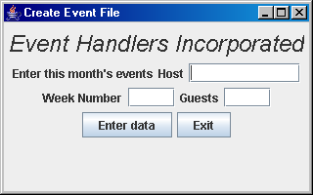

You are required to create a random access file in which you use the event’s data as the key fields. In this exercise, you assume that only one event is scheduled per week where the week number is represented as an integer value numbered from 1 to 52 inclusive. The number of guests is also an integer value and the host field is a string. Note the use of the writeUTF() and the writeInt() methods that are used to write text and integers to the file respectively. The record size is 18 which is made up of the following:

Data | Type | Size in Bytes
Host | String | 10
Week Number | int | 4
Guests | int | 4

In the GUI constructor you can create the random access file and write the blank records to it. In the actionPerformed() method you will read in the data from the textfields and write a record to the file using the writeUTF() and writeInt() methods.
Exercise 2
Write another program which will read data from the file and display the contents of a record in the various text fields on the screen. The user is asked to enter the week number at the keyboard. The interface you use is almost the same as above except that you are now asking the user to enter the week number in the text field. When the user clicks on the “Enter Week Number” button, your program will search for this record and then display the details in the text fields.

See sample output below:
When 3 is typed in the Week Number text field and the user presses the "Enter Week Number" button, the record for week number 3 is read from the file and displayed in the GUI.

